Sensor Calibration Background

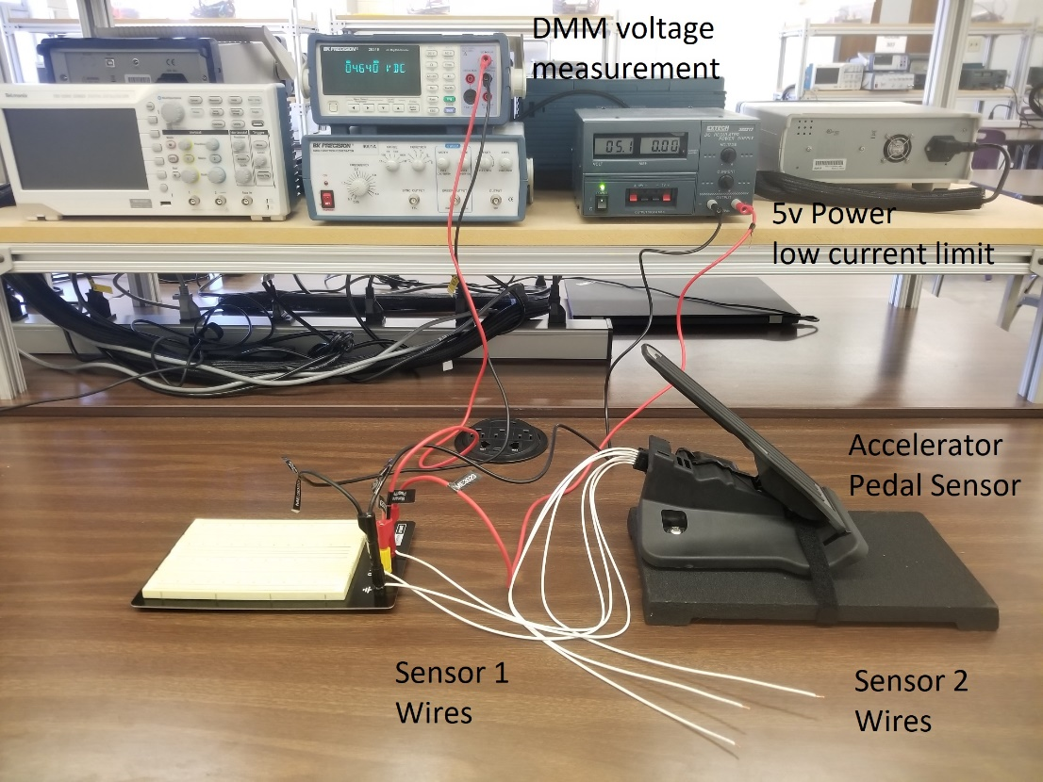

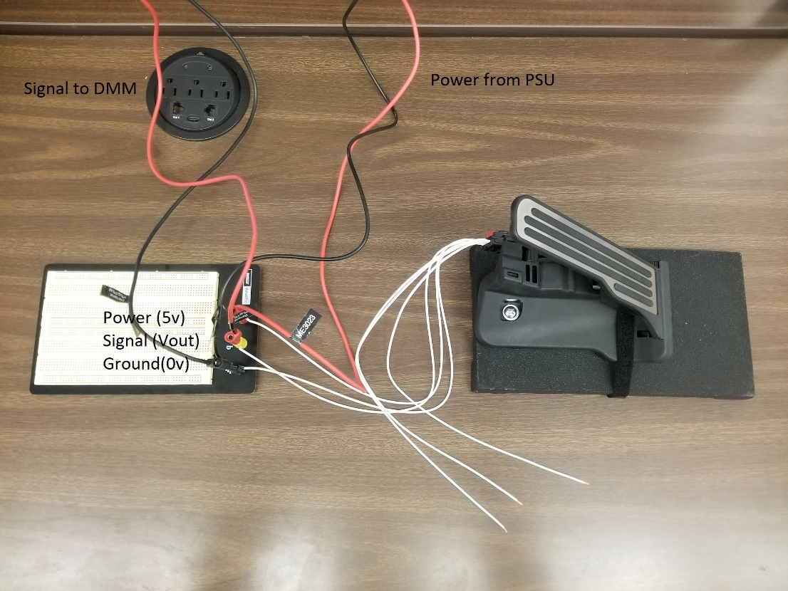

Figure 1 – Equipment Setup

Figure 2 – APP sensor wiring diagram (source: corvette forum)

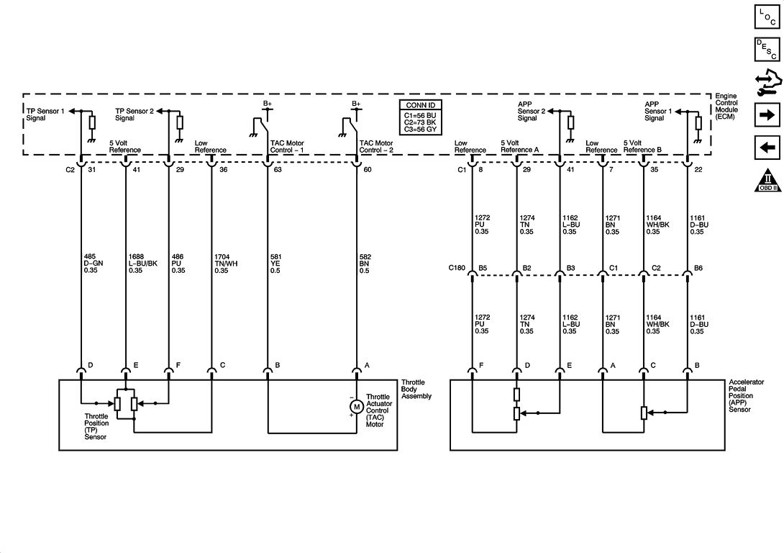Figure 3 – APP sensor connector pinout (source:

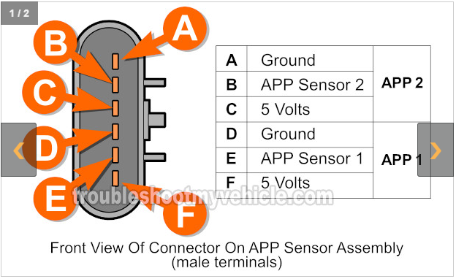

Document Bounty: 10 points for an wiring diagram with reference for GM P/N: 23418313

Linear Least Square Regression (see lecture module Calibration Topic 3 for more infomation)

(reference: Theory and Design of Mechanical Measurements Ch 4.7 – Regression Analysis)

Model:

$$y_{m}=a_{0}+ a_{1}x$$

Coefficients:

$$a_{0}=\frac{\sum_{i=1}^{N}{x_{i}}\sum_{i=1}^{N}{x_{i}}y_{i}-\sum_{i=1}^{N}{x_{i}^{2}\sum_{i=1}^{N}{y_{i}}}}{{(\sum_{i=1}^{N}{x_{i}})}^{2}-N\sum_{i=1}^{N}{x_{i}^{2}}}$$

$$a_{1}=\frac{\sum_{i=1}^{N}{x_{i}}\sum_{i=1}^{N}{y_{i}}-N\sum_{i=1}^{N}{x_{i}y_{i}}}{{(\sum_{i=1}^{N}{x_{i}})}^{2}-N\sum_{i=1}^{N}{x_{i}^{2}}}$$

Correlation Coefficient (Goodness of Fit):

$$r=\frac{N\sum_{i=1}^{N}{x_{i}}y_{i}-\sum_{i=1}^{N}{x_{i}\sum_{i=1}^{N}{y_{i}}}}{\sqrt{N\sum_{i=1}^{N}{x_{i}^{2}}-{(\sum_{i=1}^{N}{x_{i}})}^{2}}\sqrt{N\sum_{i=1}^{N}{y_{i}^{2}}-{(\sum_{i=1}^{N}{y_{i}})}^{2}}}$$